**User Manual:**

**Intro:**

Welcome to ‘All Hands on Deck’!

The game has two modes, the first is sail mode:

You must navigate yourself around the rough waters of York, visiting islands to progress. These islands may be small states, independent of the dictator Koen Lamberts, or they may be part of the oppressive ‘University of York’. Within this there are colleges - Alcuin, James and Derwent - and departments - Computer Science and Philosophy. The point here is to explore the seas, so you do not know what college or department you are at until you have travelled to it. Every island triggers an encounter, where you will be offered a choice as to your next move.

The second is battle mode:

Battles may occur in an encounter when you visit an island. If you travel to a college or department, you will be offered the choice to battle. If you have battled with a college, you can either win or lose - no running away, we are pirates not cowards! If you win the battle, you own that college, bringing you glory and gold galore. If you lose, the game ends. That’s it. No second chance. A pirate’s life is not a safe one.

To win the game, you must complete your college specific objectives. These will be revealed as the game goes on.

Do you think you have what it takes to win? Maybe? Then, let’s begin.

**Playing the Game:**

The best way to learn to play is to run through the game, significant details are emboldened.

The game starts in sailing mode. We begin our journey in Alcuin, your default college, where you can travel to the islands directly surrounding Alcuin. This idea continues throughout, **accessible islands are coloured green, inaccessible islands are coloured red**. The **island you are currently at is coloured blue**. Simply **mouse click** on an independent island - represented as an **0** - you would like to sail to next.

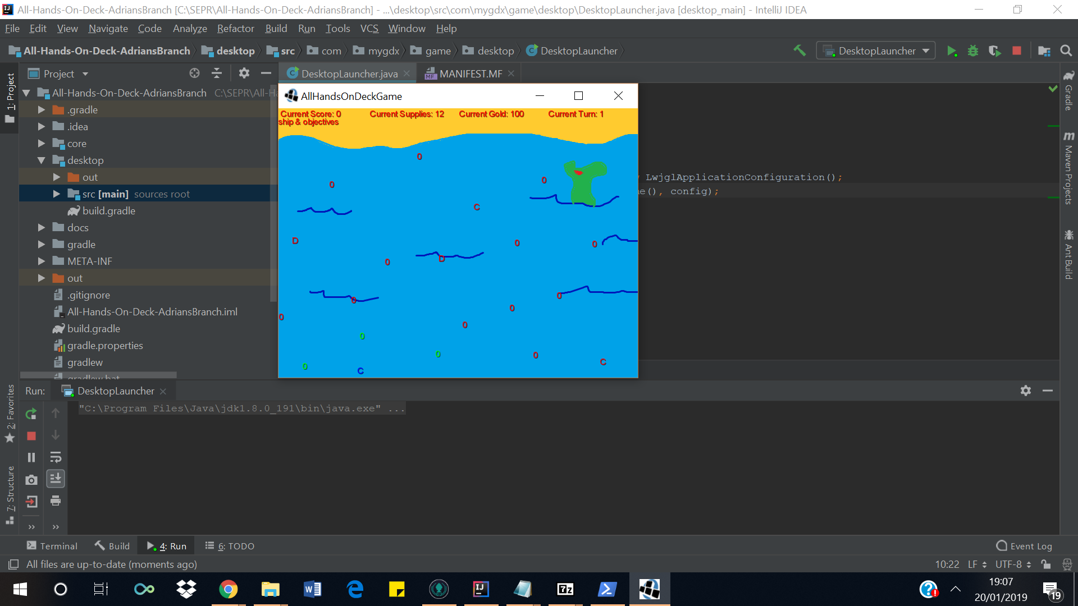

Once you have clicked the island you would like to explore, you will be experience an encounter and be given a choice. Select which option you would like to take with a **mouse click** (here we will choose option 1).



Your decision has affected your stats. Click ‘**ships and objectives’** to check them. As you can see we have lost 5 health, so now have 45/50. Notice also that this is where you can view your objectives. Click ‘**Exit**’ to return to sailing mode.

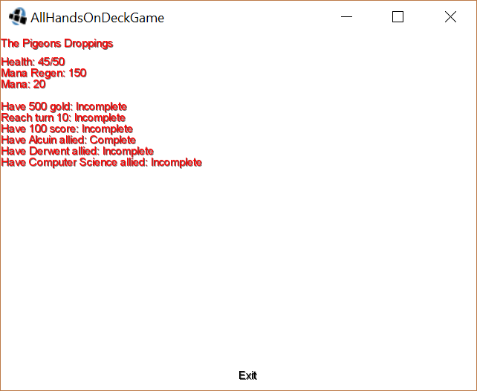

Now, click on a college (**indicated by C**) to explore. With colleges you can **buy new cards**, **buy supplies** or **attack the college**. You can also see if you are allied, 1 indicates an ally and 0 an enemy. Click **‘Attack College’** to enter battle mode.

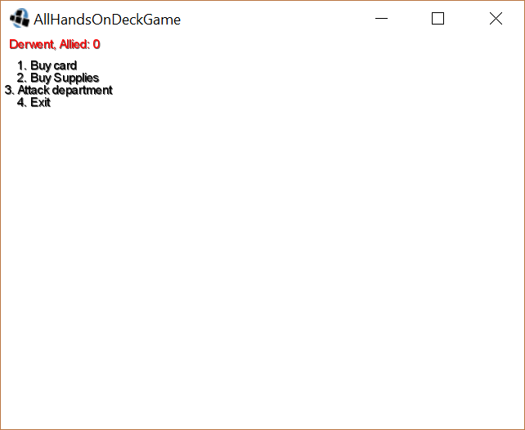

To win a battle, you must reduce the enemy ship’s health to 0. To do this, you must use your deck of cards to attack. Select a card with a **mouse click**. You can only play cards if you have enough mana (x/20), displayed in **green.**

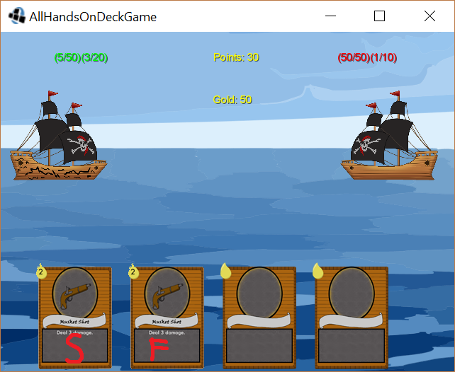

{insert pic}

The enemy ship will shown signs of damage.

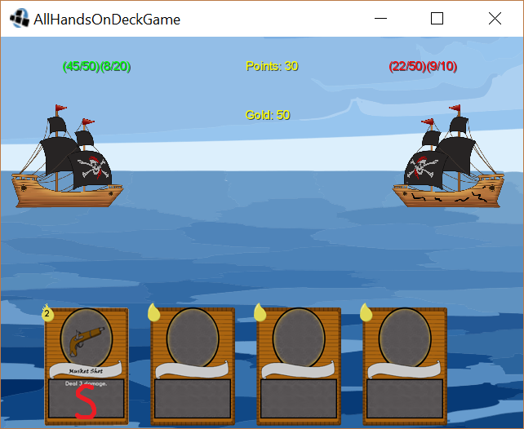

After a successful battle, your **points** and **gold gained** will be displayed. The enemy ship will also show as broken. Press **Exit** to return to sailing mode.

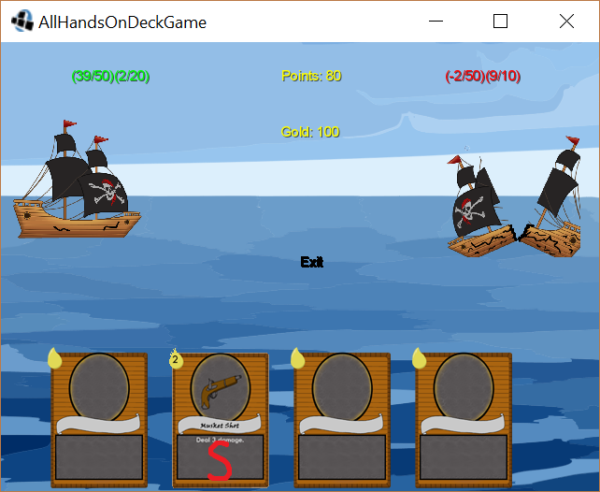

Next, select a department - **represented by D.** Departments options are **upgrade ship**, **buy supplies** or **attack department**. Make your choice and click **Exit**.

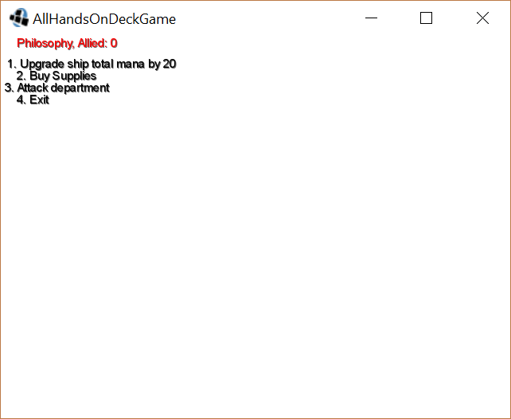

Those are the basics of how the game works, the only thing left is to show you how you lose. If you run out of resources in battle mode you lose. You can also lose the game by running out of resources in sailing mode. Either way, the end screen is displayed and your points shown.



To win, complete your objectives and win every battle - simple really!